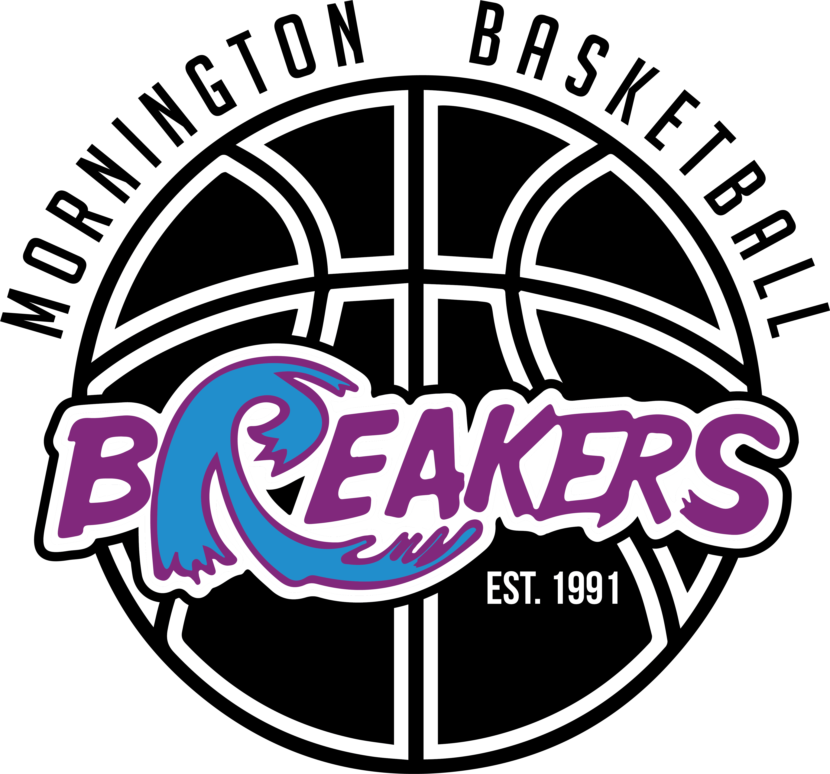
2024 Committee of Management - Nomination Form
Nominations are hereby invited for the following positions for the Mornington District Basketball Association Incorporated, Committee of Management. Nominations close at 5pm on 20th May 2024.
President 2-year term [until AGM 2026]
Secretary 2-year term [until AGM May 2026]
General Committee 2-year term [until AGM May 2026]
To be nominated requires two current members both of who must be over 18 years of age.
----------------------------------------------------------------------------------------------------------------------------------------------
We, as two current MDBA Members, both over 18 years of age
Member 1: ……………………………………………………………………Signature: ……..…………………………….…………………………………………
Mobile: ……………………..………………………………………..…………
Member 2: ……………………………………………………………………Signature: ……..……………………….………………………………………………
Mobile: ……………………..………………………………………..…………
hereby nominate ……………………………………..……………………………………………………………………………….…. for the position[s]
(circle relevant position/s below that the nominee is nominating for)
PRESIDENT SECRETARY GENERAL COMMITTEE

NOMINEE CONFIRMATION
I, ……………………………………………………………………………………………………………..……………….. agree to the above nomination[s]
Signature: ………………………………………………………………………… Date: ……../…….…/2024
Address: ………………………………………………………………………………………………………………………………………………………………………….
Phone: …………………………………………. Email: …………………………………………………………………………………………..
Please return by email to the Secretary of Mornington District Basketball Association, Ms Samantha Browne, manager@morningtonbasketball.com.au by no later than 5pm 20th May 2024.

