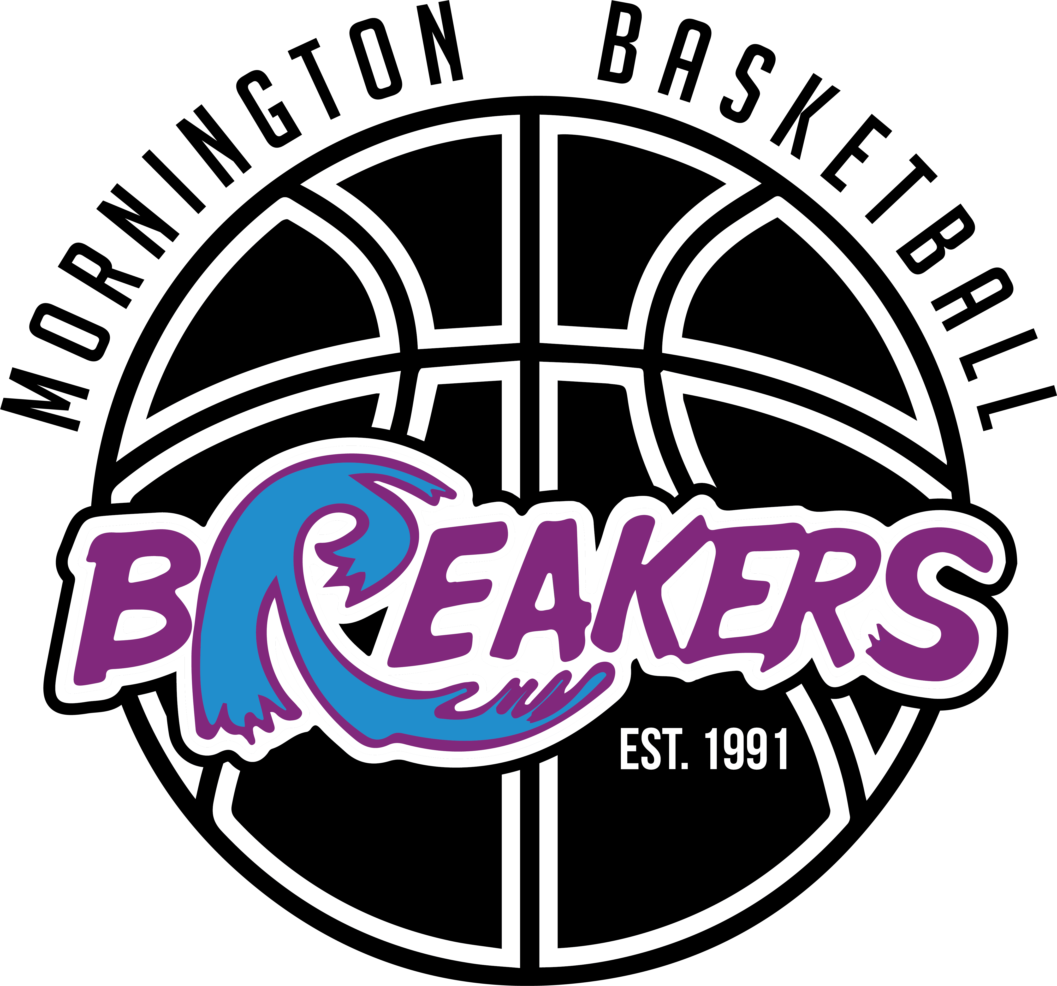

Annual General Meeting
Monday 3rd June 2024 at 7.30pm
Clubroom, 1051 Nepean Highway, Mornington

Application for nomination
Application for nomination for a position on the Committee of Management will need to be submitted by 5pm on 20th May 2024. Nominees will need to complete the 2024 Mornington District Basketball Association, Committee of Management Nomination Form available at morningtonbasketball.com.au

Biography
Each nominee is welcome to submit a ¼ page A4 document about themselves. Nominees may submit a photo, qualifications, past positions held, experience, current involvement at Mornington District Basketball Association or other clubs, what they believe they can offer or would like to offer. Profiles will be posted on the web site. Please forward your biographies to manager@morningtonbasketball.com.au.

Speech
Each nominee will be given the opportunity to make a 2-minute maximum speech at the AGM. Nominees must use the first position they nominated for as the time for their 2-minute presentation. Nominees are only able to make 1 speech regardless of how many positions they are nominating for.

Please note that the biography and speech are both optional and nominees are not required to submit a biography or make a speech.

Ballot Slip – Order of nominees
The Secretary will draw names out of a “hat” to determine the order names appear on the ballot sheet.

Voting system

- President - ✔ one box.

- Secretary - ✔ one box

- General Committee - ✔ three boxes

Returning Officer
A Returning Officer will be appointed to manage the ballot process.

Withdrawing nomination
Nominees may withdraw their nomination up to the time of the oral presentations of the position they are standing for is to commence.

